WORKSHEET

FORM: 10th
TEXTBOOK: MISSION 2 ( EXPRESS PUBLISHING)
TOPIC: SPORTS AND GAMES
LESSON : FOOTBALL MAKES HISTORY
ARGUMENT:
- Spidergram
I usually use spidergrams at the beginning of a new lesson to revise the students’ knowledge about a given topic.
Ex. I draw on the board a spidergram and I write down some words related to the topic (football), then I ask students to come up with words related to each aspect of the sport. The Spidergrams are useful because if you move from the usual structure of hand written notes and start organising your thoughts using spidergrams, then you are going to make a big step forward in improving the quality of your thinking. The biggest advantage of using this structure is that you have to think about where you are going to position your ideas in relation to the central topic and the other ideas you are considering. That process alone moves you much further up the thinking food chain.

WORKSHEET
-FOOTBALL-
TASK: complete the spidergram with words related to different aspects from football
............................... ............................
VERBS
TERMINOLOGY
FOOTBALL
PEOPLE INVOLVED
EQUIPMENT
PLACES
………………………… …………………..

…………….

The spidergram
Game, Cup Final, extra time, penalty, cup, foul, away match, draw, league, goal, match, nil, friendly match, home match, World Cup
defend, dribble, tackle, toss (a coin), kick, blow (a wistle), attack, shot, kick off, score, guards (the nests)

VERBS
TERMINOLOGY

FOOTBALL
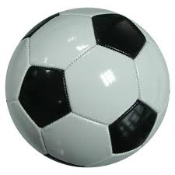

EQUIPMENT
PEOPLE INVOLVED

PLACES
goalkeeper, fans, team, football player, coach, referee, director, linesman, manager
Whistle,net, ball, goal poast, kit, football boots, yellow/red cards, linesman’s flag
stadium, stands, park, benches, changing rooms, field, pitch

